

|  |  |
| --- | --- |
| Memorandum  To: E. Santi  From: L. Merza | The Campus of The USC  Columbia, South Carolina 29208  05 February 2013  Email: Ljmerza@gmail.com |
| Subject: Technical Memorandum: Demonstration of oscilloscope usage and a switch debouncer. | |

This memo studies the effect of switches in a digital circuit. A switch is used in a digital circuit to turn a circuit on and off and this represents the 0 and 1 of the digital circuit. The problem lies in the speed of digital circuits today. Looking at the switch closely and slowing the speed of the switch, you can see the switch will bounce off the wire and causes a digital circuit to read the switch as turning on and off a few times in the millisecond time it takes for the bounce to happen. The purpose of this lab is to create a debouncer circuit (Figure A) that will get rid of the bounce that happens in switches. In order to create this circuit, three sub circuits are needed. The first sub circuit is the switch circuit itself. The switch is connected to ground and is in series with a resistor that is connected to a voltage source. The second sub circuit is a RC filter. This sub circuit is connected in between the resistor and switch. The combination of a resistor and a capacitor in the second sub circuit causes the quick nature of the bounce to be smoothed out. A large enough capacitor is used to charge up when the switch closes. A PSpice simulation was ran (Figure B) and it was found the smallest capacitor value to stop the bounce was 4nF (Figure C). In the real would circuit this value was found to be 50nF. Upon the first bounce, the switch is turned off and the capacitor is discharged. The problem is the bounce happened so fast, the capacitor didn’t charge all the way (Figure G). Each bounce causes the same partial charging and discharging until the bounce is complete and the switch is fully on. The capacitor is then fully charged finally and outputs a full voltage. Seeing this in an oscilloscope, you can see a slowly rising wave of the signal. This wave that is created by the RC filter is perfect for the third and final sub system in the debouncer circuit. The final sub circuit is the 74HC14 hex inverting Schmitt trigger. This hex inverter has two parts to it that are relevant to this circuit. The first part acts as an inverter of the signal. The second part of the hex inverter is two threshold lines. In order for the hex inverter to actually switch the signal from on to off, the incoming signal has to pass both thresholds. The wave like signal coming from the RC filter causes the line to cross the first threshold but go back down and finally back up and cross the second threshold and therefore switching the output. Putting another hex inverter in series with the first one cause the signal to be inverter again and output a signal that coincides with the original switch. These hex inverters have a propagation delay that causes a small delay in the signal’s output because of the signal having to process through the integrated chip. The propagation delay was found by taking the difference of time between the two outputs of the hex inverters at the 50% point of the switch change of the signal and was calculated to be 2.8ns (Figure I). The second circuit that was built was a unity gain inverting amplifier. This causes the signal to be a gain of -1 which means the voltage doesn’t change but the phase of the signal shifts by 180 degrees. The circuit was tested using 5kHz, 50kHz, 500kHz, and 5Mhz (Figures J, K, L, M respectively). The signal’s output is out of phase by 180 degree as expected except for the 5Mhz signal. This is because of the bandwidth limitation of the op amp itself. Finally, a pulse signal was sent in the input at 33.33kHz and this caused a skewed output (Figure N). This output is from the op amp limitation for the voltage rate of change or the slew rate.

**Appendix**

Figure A

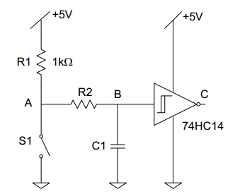

Debouncer Circuit Schematic

R2 = 1K ohms C1 = 50nF

Figure B

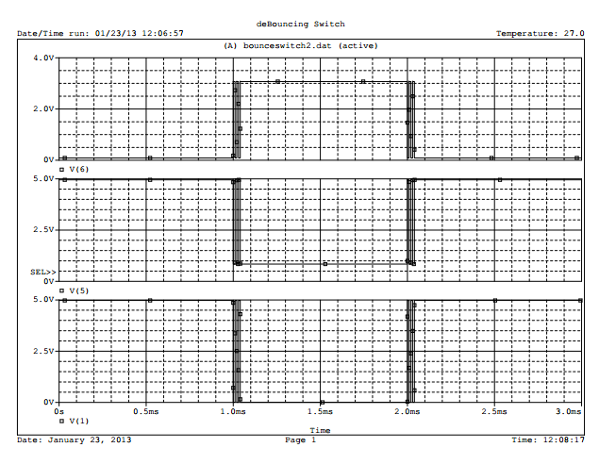

PSpice simulation of switch circuit causing bounce

Figure C

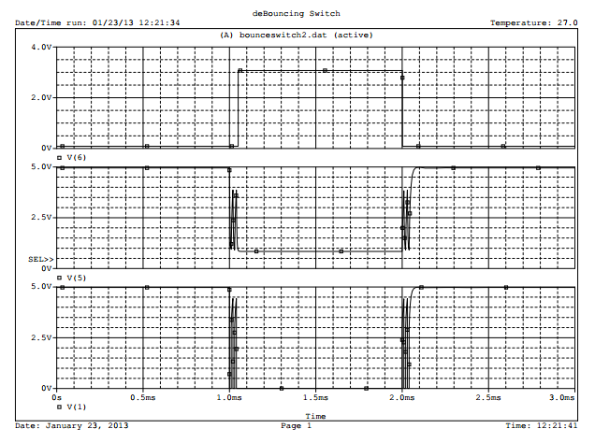

PSpice simulation of debounce circuit

1. voltage at switch (b) voltage at RC filter
2. voltage after hex inverter

Figure D

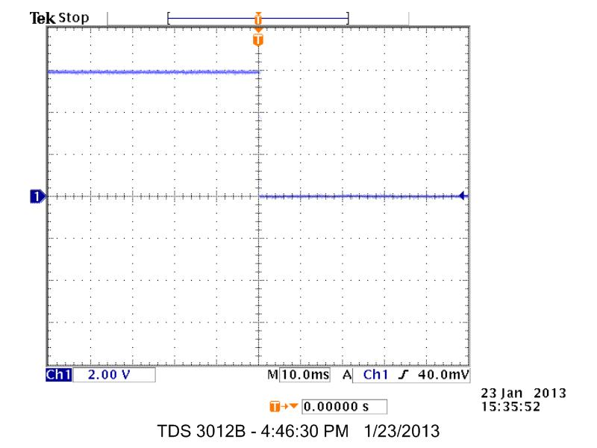

Oscilloscope view of switch bounce at 10ms per division

Figure E

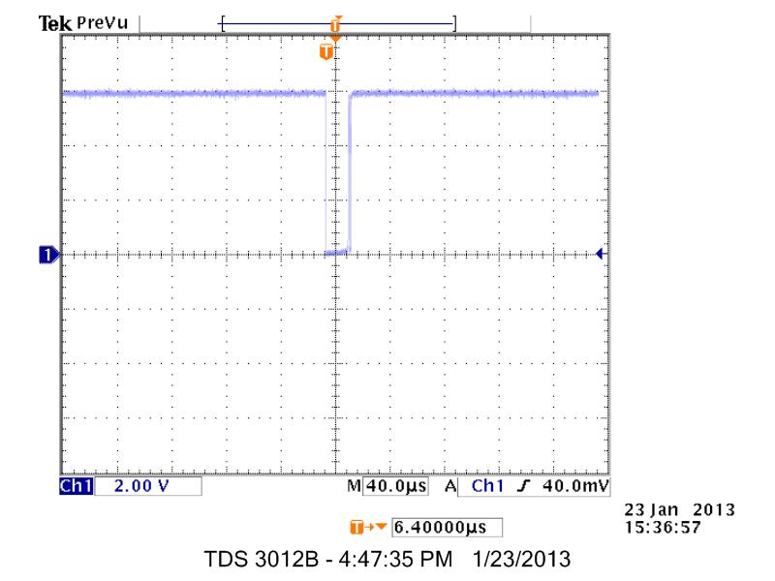

Oscilloscope view of switch bounce at 40us per division

Figure F

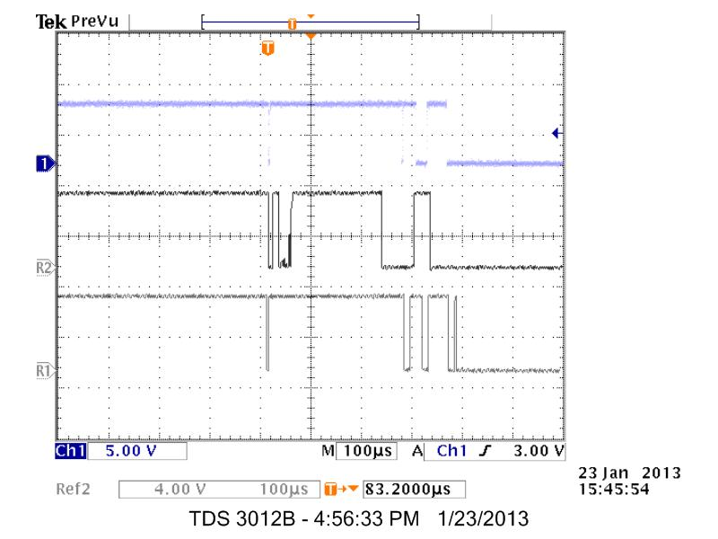

Oscilloscope view of three switch bounces

Figure G

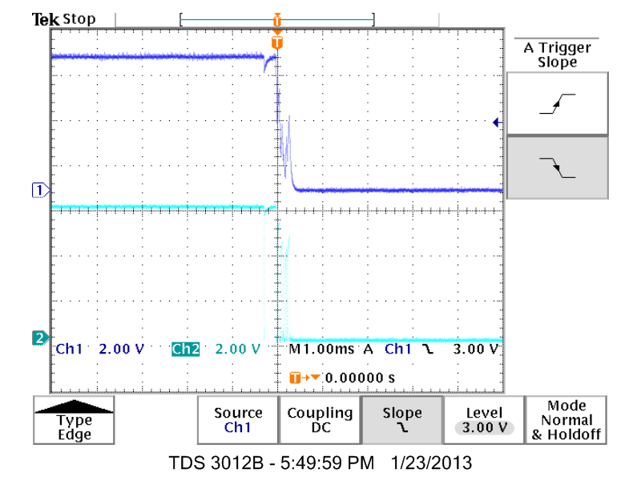

Oscilloscope view of debouncer circuit

(Channel 1) voltage at switch output

(Channel 2) voltage at RC filter output

Figure H

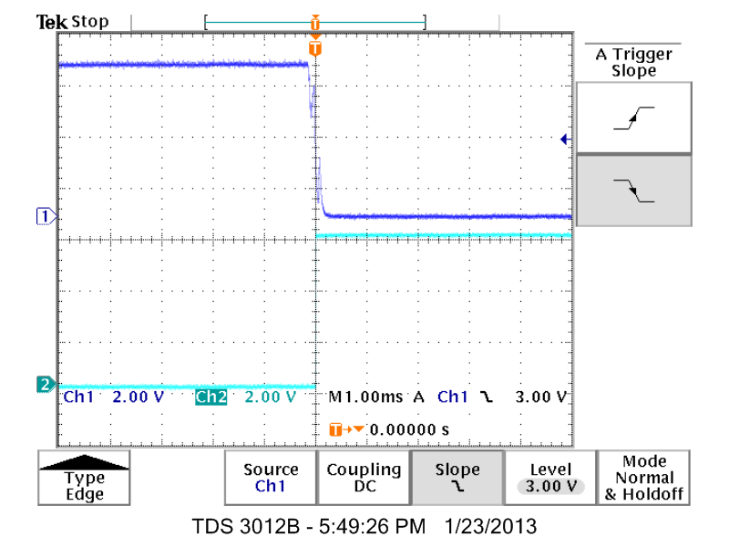

Oscilloscope view of debouncer circuit

(Channel 1) Voltage of RC filter output

(Channel 2) Voltage of hex inverter output

Figure I

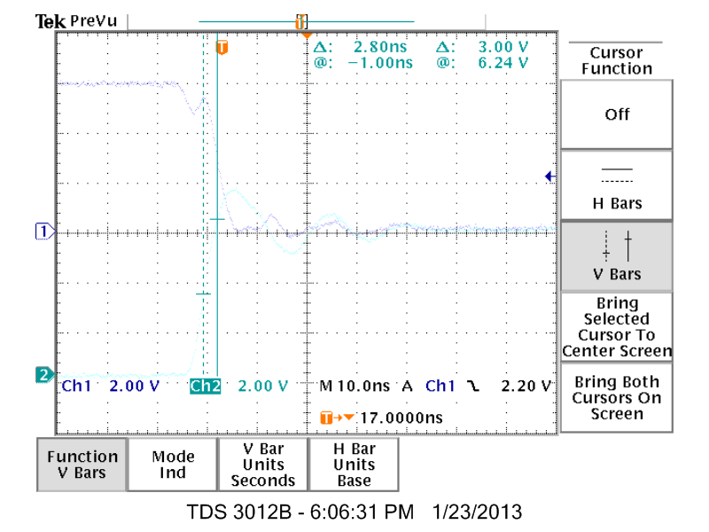

Propagation delay of two Schmitt triggers

Figure J

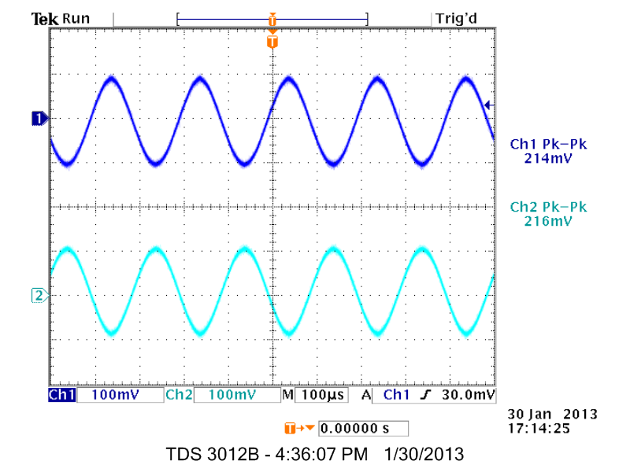

Oscilloscope view of unity gain inverting amplifier at 5khz

Figure K

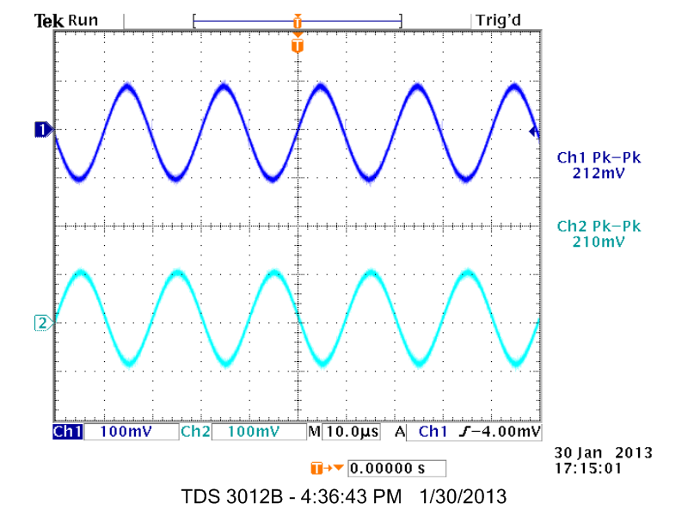

Oscilloscope view of unity gain inverting amplifier at 50khz

Figure L

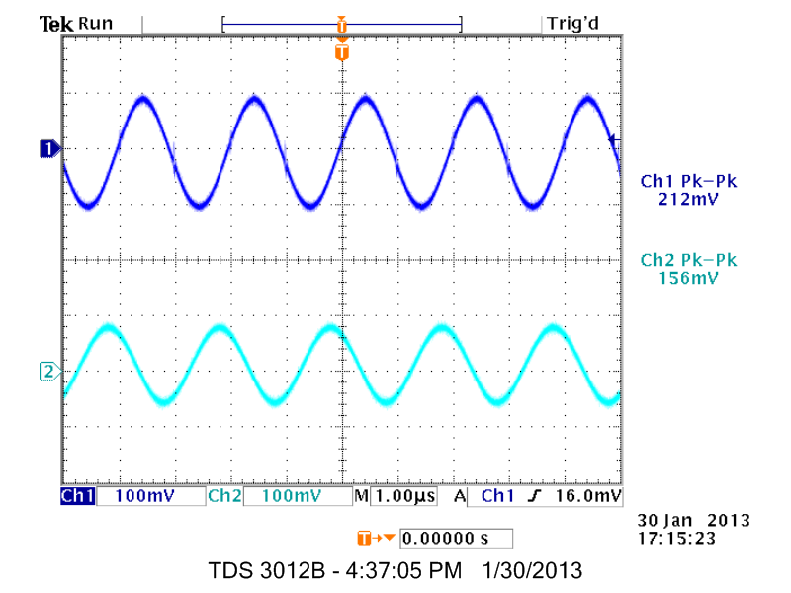

Oscilloscope view of unity gain inverting amplifier at 500khz

Figure M

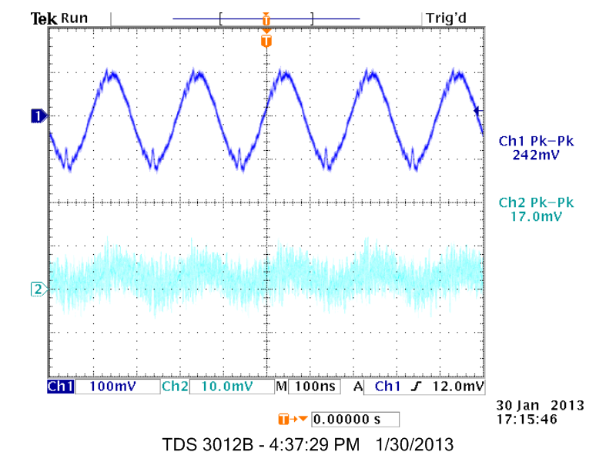

Oscilloscope view of unity gain inverting amplifier at 5Mhz

Figure N

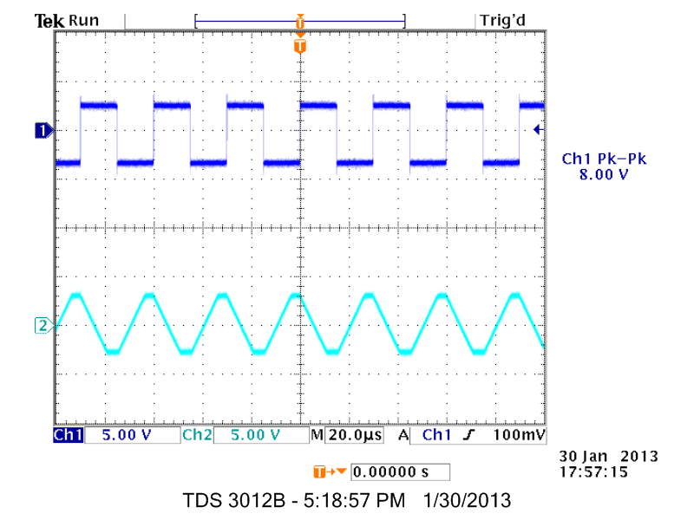

Oscilloscope view of unity gain inverting amplifier

with a pulse input at 33.33khz